**1. Introuduction**

This document will provide information about standard operating procedure to ON Miltec machines remotely at Antenna Base.

**2**. **Follow below Steps to ON Miltec Machine Remotely.**

Step 1: Open respective antennae Rabbit MCM IP (192.168.xx.4) on any browser.

Ex.

For C03 antenna , Open 192.168.34.4 IP in browser.

It will show you below New MCM Monitoring Window page.

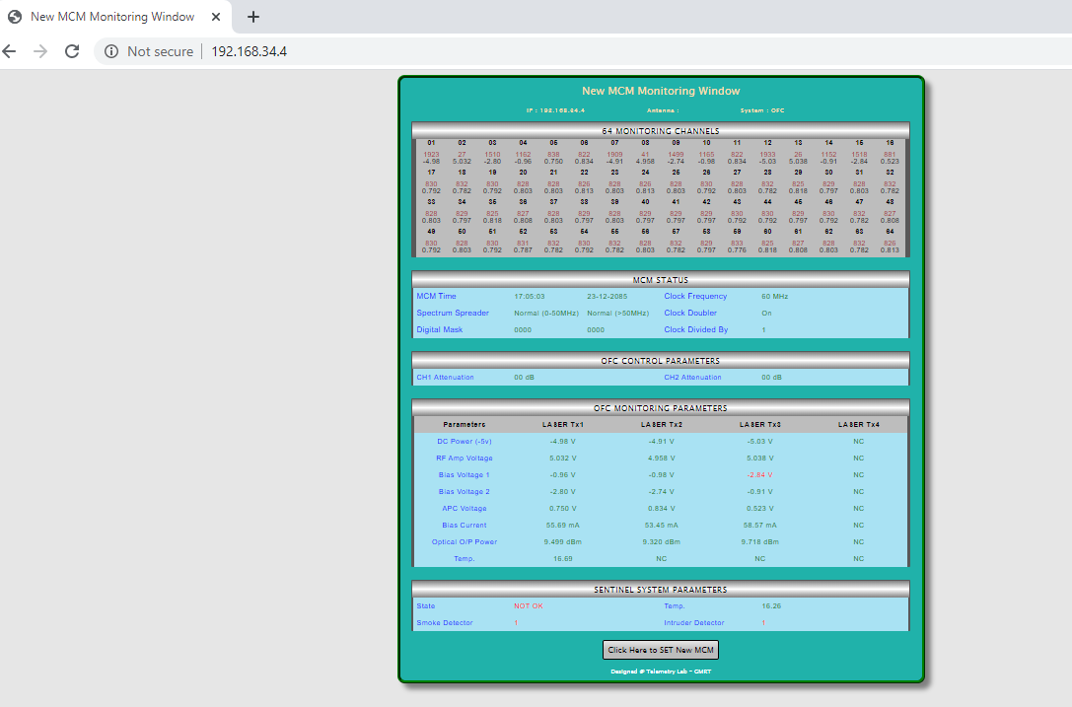

Step 2: Click on button to open New MCM Control Window

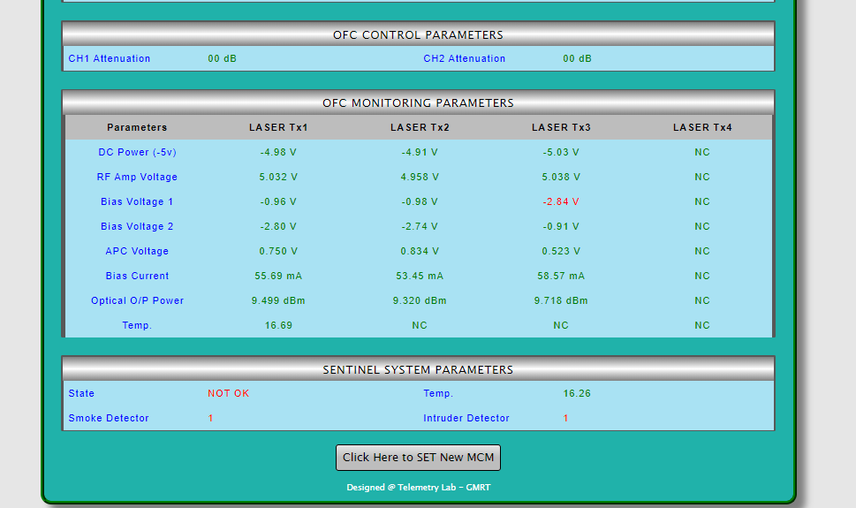

Step 3: After clicking on this button below New MCM Control window Page will open.

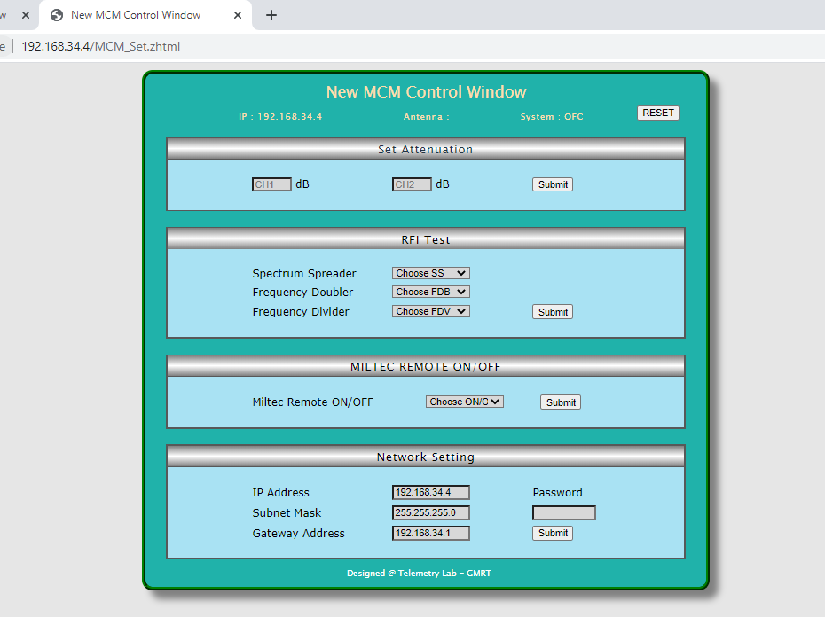

Step 4: Select ON Command from Dropdown Menu to Remotely ON Miltec Machine and click on Submit button.

